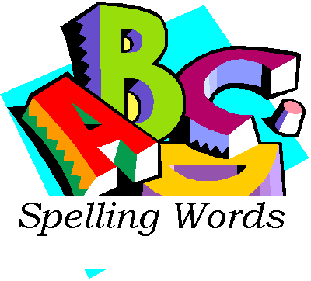
September 13, 2016

Dear Parents,

Exciting news! We will be using Vocabulary and SpellingCity in our classroom, but thanks to our Premium Membership, both students and parents will benefit from the many advantages SpellingCity reserves for its Premium Members.

Every week, I will put up a new spelling and/or vocabulary list directly on our classroom’s Vocabulary and SpellingCity homepage, which students can conveniently access from home. There, they may review their words and play spelling and vocabulary games to reinforce the learning process. The students are required to complete at least TWO of the online activities a week; that will be counted as a grade.

If you don’t have internet access at home, please let me know and I will have your student print out their spelling list and two activities here at school.

Simply go to http://www.spellingcity.com to log in your child with his/her assigned username and password.

Username: (the students First name, first 2 letters of last name, and birthday)
For example, Michellemi24
Password: (Firstname plus student number) For example, Michelle74562

Once logged in, students are automatically redirected to our classroom’s homepage, where their spelling and vocabulary lists will be clearly visible, just below my Welcome Message & Daily Instructions. Please be sure that every time your child accesses Vocabulary and SpellingCity, s/he is logged in so that all activities can be recorded and credited.

For your convenience, you can access your child’s student records at any time by selecting “My Records” from the menu in the upper right hand corner. I ask that you please encourage your child to spend about ten minutes each night working with his/her assigned words on Vocabulary and SpellingCity over the four consecutive nights preceding our weekly test. Working together as a team will go a long way toward not only guiding our students to academic success, but also ensuring that they become independent, lifelong learners.

Sincerely,
Michelle Miller

